<<Social Network for Musicians>> :

1. **Introduction:**

1.1. Aim of the document:

* This document aims to give an overview of the system and what it does, explicating also the functional requirements that must be implemented in the system.

1.2. Overview of the defined system:

* Meet musician and form a band, asking for someone to play something, make me know as a musician, discussing musical topics with other users in a forum based on Q\A, an evaluation system about samples or answers.

1.3. Operational settings:

* Web-App (Website).

1.4. Related systems (at least 2), Pros and Cons: *“VillaggioMusicale”* – *“Fiver”:* **Pros:** Informations about concerts; Possibility to be paid if an user plays something

**Cons:** Less concentrated about music and musicians that are not famous yet; Not possibile to talk directly to other musicians and/or bands.

1.1. Glossary:

* *Instrument = Accordion, Bagpipe, Balalaika, Banjo, Bass, Berimbau, Bouzouki, Cello, Cetra, Clarinet, Clavichord,

Contrabass, Drum, Flute, Gable, Guitar, HarmonicĂ, Harp,

Harpsichord, Horn, Keyboard, Lira, Lute, Mandolin, Microphone, Oboe, Ocarina, Organ, Piano, Saxophone, Sitar, Spinet, Trombone, Trumpet, Violet, Violin, Xylophone.

* *Personal data = first name, last name, birth date, place of residence, email, username, password.
* *Evaluation System = Users click on stars, from 1 to 5. The final rate is the medium between all the rating votes.

•*Moderate Users = Ban, Warning, Restriction to users.

2. User Stories:

* 1. As a musician, I want to register myself into this system, so I can find a band to play with. (V. V.)
* 2. As a music lover, I want to discuss about music in topics, so I can increase or share my knowledge. (V. V.)
* 3. As a user, I want to have a score system about, so I can see how much I’m active on the system. (V. V.)
* 4. As a musician, I want my samples to be evaluated by other users, so I can get feedback. (A. C.)
* 5. As an admin, I want to write the rules of the system, so I can make them visible to users. (A.C.)
* 6. As a user, I want my profile to show the instruments I play and the years of experience I have for each one, so I can be seen from other users. (A. C.)
* 7. As a musician, I want to exchange samples with other users, so I can share music files. (L. M.)
* 8. As a musician, I want a filtering system, so I can find other users easily. (L. M.)
* 9. As a user, I want a mail service, so I can communicate with other users. (L. M.)

3. Functional Requirements:

* 1. The system shall show users’ requests in a chronological order of insertion (last insered, first showed) into a notice-board. (V. V.)
* 2. The system shall provide a mailing system, in which users can send messages and files. (V. V.)
* 3. The system shall implement an evaluation system*, for rating people samples and answers.

(V. V.)

* 4. The system shall show, on users' profile, personal picture, first name, last name, age, city of residence, played instruments, years of experience for each one, name of his band/s, role/s in the band/s. (A. C.)
* 5. The system shall allow the user to filter the list of requests based on the instrument specified, and the date on which the request was made. (A. C.)
* 6. The system shall provide a forum where users can ask and answer those of other users. (A. C.)
* 7. The system shall provide user registration, inserting personal data* and also the instrument* played. (L. M.)
* 8. The system shall show all availables users in a notice-board to do samples for other users, showing instrument played. (L. M.)
* 9. The system shall provide a ranking of users based on evaluations (more ratings, more high in ranking), and each month the first 20 users are considered advanced (the old 20, became normal users). (L. M.)

4

. Use Cases

: 

Overview

Diagram

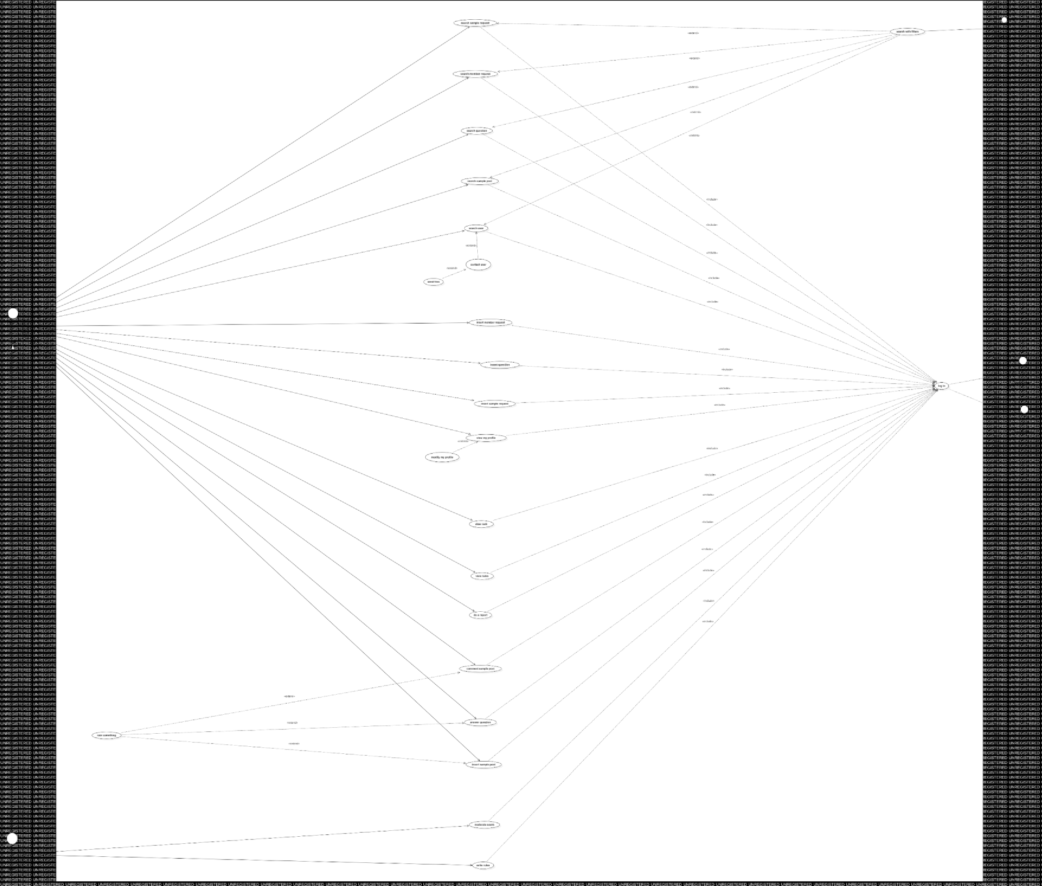

: 

5. StoryBoards:

• 5.1. Mail Service (L.M.)

• 5.2. Sample Posts (L.M.)

• 5.3 Search Members/Bands (A.C.)

• 5.4 Ranking (A.C.)

• 5.5 Questions/Answers (V.V.)

• 5.6 Home (V.V.)

# 5.1. Mail Service (L.M.)

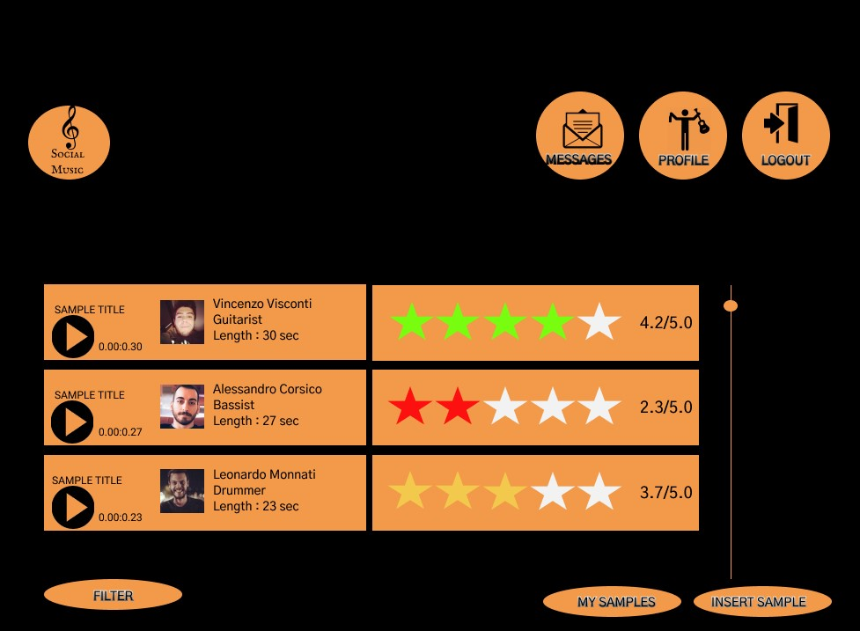5.2. Sample

Posts (L.M.)

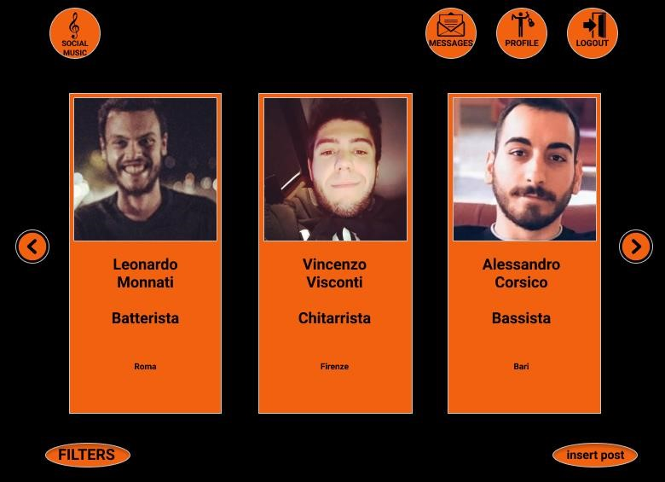5.3 Search Members & Bands (A.C.)

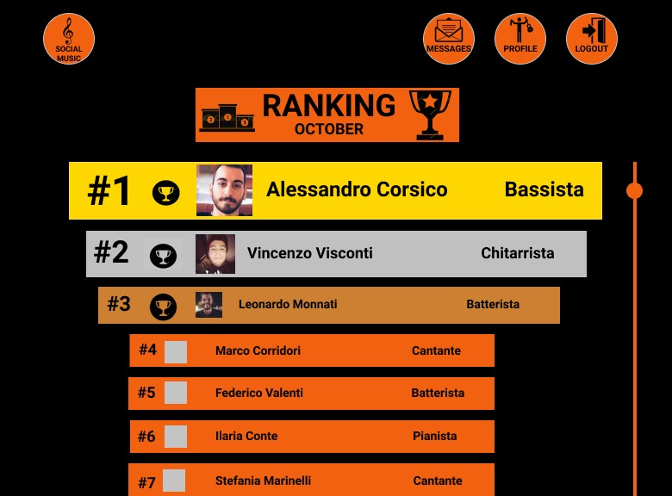5.4 Ranking (A.C.)

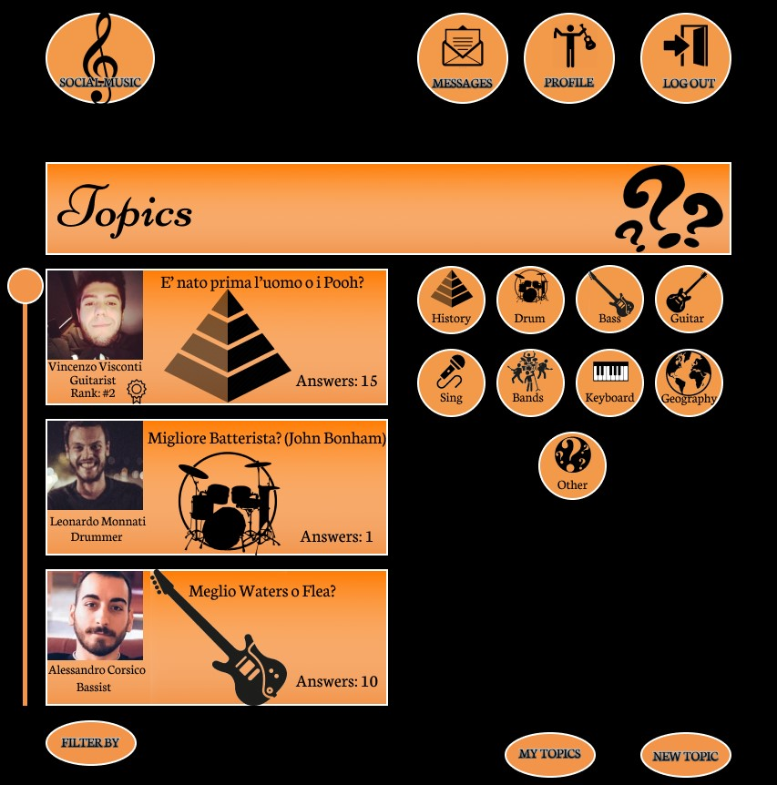5.5 Questions & Answers (V.V.)

# 5.6 HomePage (V.V.)



6. Activity Diagram :

•6.1 Insert Sample post + Login (V.V.)

•6.2 Contact User + Mail System (L.M.)

•6.3 Evaluate Samples (A.C.)

# 6.1 Insert Sample Post + Login (V.V.)

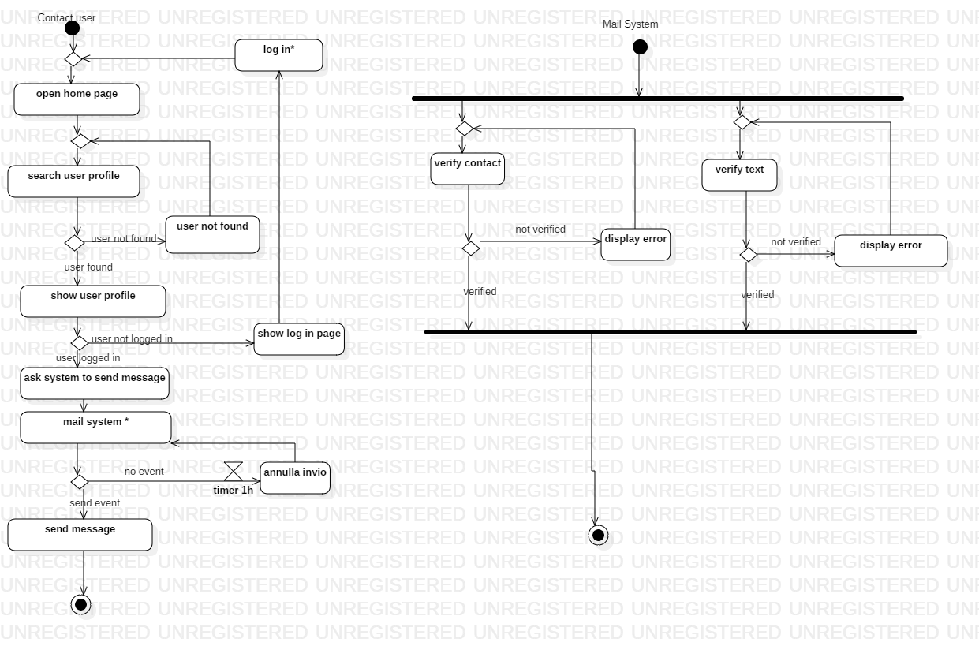6.2 Contact

Users (L.M.)

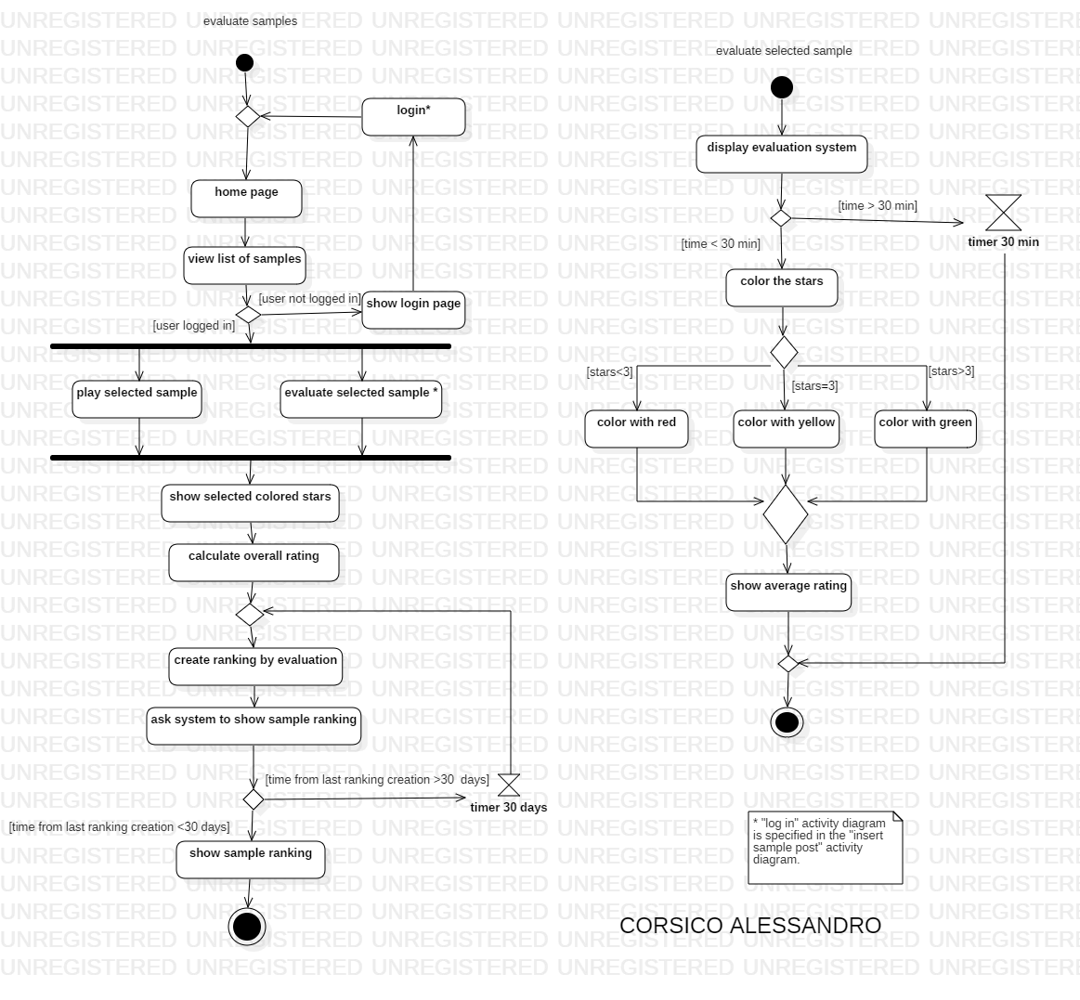6.3 Evaluate

Samples (A.C.)

7. GitHub - Travis – SonarCloud :

* URL GitHub: <https://github.com/VincenzoVisconti16/Social-Music>
* URL Travis: <https://travis-ci.org/VincenzoVisconti16/Social-Music>
* URL SonarCloud: <https://sonarcloud.io/dashboard?id=VincenzoVisconti16_Social-Music>